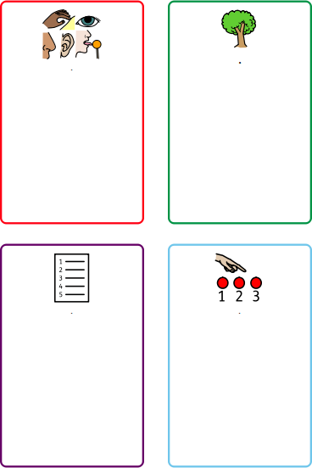
I am a strong tree
- I stand with your feet planted firmly on the ground like the roots of a tree.
- I keep my body tall and straight like the trunk of a tree.
- I place my arms out or above my head like the branches of a tree.
- I breathe in and out slowly like the wind, and gently sway my arms.
Counting
Complete a counting challenge, for example:
- Count back from 98 in 7s.
- Count to 100 in 2s
- Start doubling from 1. How far can you go?
- Count in 3s

Categories
Name 10 items from 3 different categories. Some ideas are:
- Harry Potter characters
- Pokémon
- Movies
- Sports
- Colours
- Cities
5,4,3,2,1 Technique
Name:
- 5 things you can see
- 4 things you can feel
- 3 things you can hear
- 2 things you can smell
- 1 thing you can taste

