A mental health, wellbeing, and suicide prevention policy for:

Start date: Review date:

How to use this policy template:
This policy template applies to all organisations regardless of size, industry, or nature of business. Unlike many health and wellbeing policies, it includes specific measures and guidance around suicide and suicide prevention.
To adapt this policy for your organisation, you may wish to assess the measures you already have in place to manage staff mental health and wellbeing and/or suicide. Determine if any of these need improving and if there are any risks that aren’t currently being addressed. The ISO’s Psychological health and safety at work guidelines provides guidance on aspects to consider.
Staff should participate in the adaptation of this policy. Their input is invaluable, and their involvement is likely to increase motivation and commitment in building a healthier and safer workplace.
We recommend this policy is used in conjunction with the suicide prevention guidance from CIPD and the Business in the Community (BITC) Suicide Prevention Toolkit which was produced in partnership with Public Health England and supported by the Samaritans. These will help embed suicide prevention strategies in your organisation’s health and wellbeing policies & guide your approach to supporting those at risk.

The Mental Health at Work Commitment
The Mental Health at Work Commitment and the standards which underpin it are an industry recognised roadmap to achieving better mental health outcomes for those in work. The standard is a set of actions that any organisation can follow to improve and support the mental health of their workforce. This policy template is mapped against the standards of the Mental Health at Work Commitment (see Appendix C).

Policy Contents

- About this policy
- Legal obligations
- Understanding stress and mental health
- Understanding suicide
- Policy objectives and actions
  - Addressing stress in the workplace
  - Creating conditions for good mental health to thrive
  - Promoting the importance of physical activity and healthy eating
  - Embedding mental health and suicide prevention in company culture
  - Equipping staff with the right knowledge and skills
  - Providing timely and appropriate support
  - Routine monitoring and accountability
  - Practical Suicide Reduction and Risk Assessment
  - Responding to a suicide or a suicide attempt
  - Workplace support after a suicide or suicide attempt
- Summary of responsibilities
- Review period
- Appendices
  - Appendix A: National and Local Signposting
  - Appendix B: Key Knowledge Recap
  - Appendix C: Mental Health at Work Standards Mapping
  - Appendix D: Process to follow for suicide within the workplace
  - Appendix E: Process to follow for attempted suicide within the workplace
  - Appendix F: Guidance on impact of suicide and suicide attempt upon an operational site/place of work
- This section of the policy should outline the health and wellbeing values for your organisation, the purpose of the policy and who it applies to.  We have included 4 example clauses. | - About this policy  - We are committed to protecting the health, safety and wellbeing of our staff. We recognise the importance of identifying and tackling the causes of work-related stress and having procedures in place around suicide. We also recognise that personal stress, while unrelated to the workplace, can adversely affect the wellbeing of staff at work.  - The purpose of this policy is to set out the measures we have in place to support the mental wellbeing of all our staff, including measures to prevent, intervene and respond around suicide.  - The actions stated in this policy show our commitment to a whole organisation approach to mental health and suicide prevention  - This policy applies to all employees, officers, consultants, self-employed contractors, casual workers, agency workers, volunteers, and interns.
- This section highlights the legal frameworks the policy relates to.  These are applicable to all organisations. | - Legal Obligations  - We have a legal duty to take reasonable care to ensure that your health is not put at risk by excessive pressures or demands arising from the way work is organised.  - This policy takes account of our obligations under the Health and Safety at Work etc Act 1974, Management of Health and Safety at Work Regulations 1999, Employment Rights Act 1996, Protection from Harassment Act 1997, Working Time Regulations 1998 and Equality Act 2010.
- Use this section to define the main topics of the policy. You may wish to add details such as:  - The benefits of positive wellbeing in the workplace  - Statistics on how common mental health issues are in your sector | - Understanding stress and mental health  - Stress is the adverse reaction people have to excessive pressures or demands placed on them. Stress is not an illness but, sustained over a period of time, it can lead to mental and/or physical illness.  - Mental health is a term to describe our emotional, psychological and social wellbeing; it affects how we think, feel and act and how we cope with the normal pressures of everyday life. Positive mental health is rarely an absolute state since factors inside and outside work affect mental health, meaning that we move on a spectrum that ranges from being in good to poor mental health.  - There is an important distinction between working under pressure and experiencing stress. Certain levels of pressure are acceptable and normal in every job. They can improve performance, enable individuals to meet their full potential and provide a sense of achievement and job satisfaction. However, when pressure becomes excessive it produces stress and undermines mental health.  - Pressures outside the workplace, whether the result of unexpected or traumatic events such as accidents, illness, bereavement, family breakdown or financial worries, can result in stress and poor mental health. They can also increase normal workplace pressures.
- Use this section to define the main topics of the policy. You may wish to add details such as:  - The highest risk industries for suicide in the UK  - The extent of suicide in your county | 4. Understanding suicide  4.1 The World Health Organisation defines suicide as the deliberate act of taking one’s own life. This policy recognises suicide as a spectrum to include those experiencing suicidal thoughts, those with a plan for suicide, those who have attempted suicide, those who have died by suicide and those affected by a suicide. One in five adults in the UK will experience suicidal thoughts in their lifetime.  4.2. Suicide rarely has a single cause. An issue or combination of issues such as job insecurity, discrimination, work stressors and bullying in the workplace may add to external factors that put someone at greater risk of developing suicidal thoughts and taking their own life.  4.3. Mental health and suicide are often related, but not always. It’s important to recognise that someone can be experiencing suicidal thoughts or take their own life without having a mental health condition.  4.4. The majority of people who die by suicide have never seen a mental health professional or been diagnosed with a mental illness so the workplace is well-placed to spot signs and signpost to support.
5. Policy objectives and actions (sections 5a-5j). These objectives should be measurable & achievable – Each objective is accompanied by actions. These should be tailored to your workplace & can be scaled up or down as needed.  a) The law requires employers to tackle work-related stress.  We’ve provided some example actions  The Health and Safety Executive has a range of tools and resources on how to manage and measure stress in the workplace: https://www.hse.gov.uk/stress/ These can be used to support the example actions on the right or to create new content for your policy. | Think about the features of your business and any specific factors you’ll need to cater for. For example, you may need to take into account the needs of particular groups of workers (e.g. remote workers, minority groups).  - Addressing stress in the workplace  We will:  - Take account of stress and mental wellbeing when planning and allocating workloads.  - Monitor working hours and overtime to ensure that staff are not overworking and monitor holidays to ensure that staff are using their entitlement  - Ensure risk assessments include or specifically address work-related stress.  - Facilitate requests for flexible working where reasonably practicable [in accordance with our Flexible Working Policy].  - Ensure that in any workplace reorganisation our change management processes are designed to minimise uncertainty and stress.
5.b) Employers have a duty of care to support the mental health and wellbeing of employees.  Mental health and suicide are strongly linked, so developing a mentally healthy workforce is a key strategy for suicide prevention.  We’ve provided some example actions. | - Creating conditions for good mental health to thrive in the workplace  We will:  - deliver a programme of activity to promote good mental health across the workplace, which will include organising activities to strengthen relationships between staff.  - provide good physical workplace conditions, including air quality, lighting, temperature, and noise  - create regular opportunities for employees to feed back when work design, culture and conditions are driving poor mental health  - prevent and take action against bullying and harassment – complaints of bullying and/or harassment, or information from staff relating to such complaints, will always be dealt with fairly, confidentially and sensitively. [insert link to relevant policy]
5.c) Embedding good physical health in the workplace is proven to help maintain good mental health and wellbeing.  We’ve provided some example actions. | - Promoting the importance of physical activity and healthy eating for managing stress and maintaining mental wellbeing  We will:  - Provide information on the ways that physical activity & healthy eating can help manage stress and physical pain, as well as improving concentration (leaflets, talks, courses)  - Encourage lunchtime activity groups and regularly encourage staff to take sufficient breaks away from their desks  - Provide easy access to cold water in all offices and meeting rooms  - Offer healthy menu options
5.d) Creating a culture where staff feel safe to admit they are struggling and feel their wellbeing is consistently considered is key to prevention and intervention.  Organisations that succeed in this create opportunities for effective support at an early stage.  We’ve provided some example actions. | - Embedding mental health and suicide prevention in company culture  We will:  - regularly ask about employee wellbeing, encourage openness about mental health during recruitment and throughout employment  - ensure good mental health as an important topic is communicated across the organisation  - hold organisational events and learning opportunities to increase awareness around mental health, wellbeing and suicide prevention, and challenge mental health stigma  - appoint workplace champions [insert info about your Mental Health First Aiders or other champions here] across the organisation  - put staff wellbeing on team agendas and in all 1:1s  - convey to all managers the importance of talking with employees about mental health and wellbeing and provide the support and skills for them to do so
5.e) Build staff confidence and capability in spotting and managing early signs of work-related stress and ill health.  Increasing knowledge & skills around these topics does not increase the likelihood of poor mental health or suicides in the workforce. It allows staff to spot signs and creates opportunities to provide support around issues that already exist.  We’ve provided some example actions.  Different organisations will have different training needs. Identify what level of competence is needed for your organisation & create actions to support staff to reach this goal.  If you need a free model of training, we recommend making either We need to talk about suicide (nwyhelearning.nhs.uk) (90 mins) or Free online training from Zero Suicide Alliance (20 mins) mandatory for all staff and embedding  https://www.healthyminds.whct.nhs.uk/nwt-suicideprevention in accompanying information. | - Equipping staff with the right knowledge and skills  We will:  - ensure all staff are notified of this policy at induction, make it accessible to all and empower employees to actively contribute to and feed back about it  - provide opportunities for staff to learn about how to manage their own mental health and be aware of the key stressors that might affect themselves & others at work.  - prepare and educate staff to have effective conversations about mental health and suicide  - include basic suicide prevention training in inductions  - educate line managers in spotting and supporting all aspects of mental health in the workplace, including suicide, and provide them with regular refresher training  - support managers to think about employee mental health in all aspects of their role including during staff inductions, one-to-one meetings, team meetings and return-to-work meetings  - ensure senior staff members are all aware of common mental health conditions and the impact these can have at work
5.f) One of the easiest ways you can support your employees is to make sure people are aware of the help, tools, and services available to them.  These need to be actively and openly promoted by staff at all levels.  We’ve provided some example actions.  We recommend you insert relevant organisation links into this section, for example, details of your Employee Assistance Programme if you have one and relevant staff wellbeing webpages.  If you don’t have an intranet, insert information here on what process staff should follow internally if there are concerned about their own or others wellbeing. | - Providing timely and appropriate support to those who need it  We will:  - Ensure resources and tools to support staff wellbeing internally are available and regularly promoted.  - Actively make staff aware of external help available for mental health and wellbeing in case they are not comfortable receiving support through the workplace. [Insert info on where this can be found – this should include NHS services and non-digital support]. A list of local and national support is available at the end of this policy (see Appendix A).  - promote support around key contributors to poor mental health e.g. debt, loneliness  - ensure our induction process and refresher training for line managers makes them aware of these resources and tools and of their responsibility to promote them routinely as part of their role.
5.g) Monitoring staff wellbeing is an important aspect of organisational commitment to mental health & wellbeing and suicide prevention. It also allows you to act appropriately and promptly when needs are identified.  We’ve provided some example actions | - Routine monitoring and accountability  We will:  - routinely monitor employee mental health and wellbeing using our available data  - provide appropriate supervision for our Mental Health First Aiders / workplace champions to support them in their role [Insert information/links]  - require that line managers at every level ask employees routinely about wellbeing as part of their regular supervisions  - create clear opportunities for the organisation to make improvements around health and wellbeing based on employee feedback.
5.h) A whole organisational approach is essential to suicide reduction. Practical operational steps are needed to achieve this.  This section will need to be tailored to the operational needs of your organisation.  We’ve provided some example actions | - Practical Suicide Reduction and Risk Assessment  We will:  - ensure risk assessments are conducted for locations and materials that can be used for suicide within the workplace. These will consider the risk posed by an individual considering suicide.  - ensure our Sickness and Absence policy reflects support and compassionate leave for any employee who responds to a suicide or potential suicide in the workplace, who is bereaved by suicide or who is returning to work after a suicide attempt  - make it clear that it is not a line manager’s or staff member’s job to assess the level of risk of suicide in an individual. If a line manager or staff member has any concerns at all then they should ask about suicide directly, make the person aware of support available and use their training to identify best next steps. A senior staff member should be informed.  All staff should be suitably prepared to have effective conversations around mental health and asking about suicide but under stress people can sometimes forget training. This policy provides a recap of key knowledge (See Appendix B)
5.i) No policy can ever eliminate the risk of suicide. Someone dies by suicide every week across Herefordshire and Worcestershire.  Organisations should be prepared to respond to a suicide or a suicide attempt.  We’ve provided some recommended guidance.  Check the information to make sure it corresponds with emergency response/crisis management procedure for your organisation. | - Responding to a suicide or a suicide attempt  Appendix D and Appendix E share procedures that should be followed if there is a suicide or suicide attempt in the workplace.  - Crisis Management In The Event Of A Suicide: A Postvention Toolkit For Employers - Business in the Community (bitc.org.uk) is designed to support employers in their response to the suicide of an employee, at work or outside the workplace. It was produced in partnership with Public Health England and supported by Samaritans.  - Appendix F offers guidance on how to physically manage an operational site/place of work after a suicide or suicide attempt.
5.j) When a colleague dies or attempts suicide, there can be feelings of guilt, shock, and grief across the workforce.  The impact should not be underestimated, and steps need to be taken to ensure the overall psychological health of staff.  We’ve provided some example actions | - Workplace support after a suicide or suicide attempt  We will:  - recognise that the reactions to suicide or suicide attempt will vary across the workforce, and that a range of interventions will be required to support colleagues  - Following an incident of completed or attempted suicide within the workplace, or that of a colleague, we will:  - Provide counselling and/or signposting to support for any employee affected by the incident  - support staff in organising a response, tribute, or memorial.
6. This section summarises who holds what key responsibilities in the organisation in relation to the policy.  We have provided some example clauses. | 6. Summary of responsibilities  Managers have a responsibility to:  - Ensure that all staff are made aware of this policy  - Ensure that all staff actively support and contribute to the implementation of this policy  Employees have a responsibility to:  - understand this policy and seek clarification from management where required  - consider the policy while completing work-related duties or representing the organisation  - support fellow staff in their awareness of this policy  - support and contribute to our aim of providing a mentally healthy and supportive environment for all staff  All staff have a responsibility to:  - take reasonable care of their own mental health and wellbeing as well as their physical health  - alert their line manager or a Mental Health First Aider if they notice that their mental health is slipping or that they are struggling at work  - take park in constructive conversations about what support or reasonable adjustments can be made to support them at work or on their return to work after a period of illness  - stay in touch during time off work  - avoid using stigmatising language about people with mental health conditions and avoid discriminatory behaviour
7. Review period  We have provided some example clauses. | - Review period  This policy will be reviewed after six months then once/twice yearly thereafter. Effectiveness of the policy will be assessed through:  - feedback from staff and management  - reference to the impact measurements detailed above  - review of the policy by management to determine if its overall objectives have been met and to identify barriers to ensure that progress is sustained.  Sign Off:  Name:  Title:  Signature:  Date:  Date of next review:

- Appendices:

- Appendix A: National and Local Signposting

Herefordshire and Worcestershire Health and Care Trust:
https://www.healthyminds.whct.nhs.uk/nwt-suicideprevention
If you’re feeling overloaded, no matter what your background or situation, we’re here to offer you support. Don’t feel like you have to struggle alone – talking can help. We have trained staff available 24/7 who can listen to you and provide advice & support. Calls are free and confidential.

Directories of local support
https://www.worcestershire.gov.uk/info/20470/mental_health_and_emotional_wellbeing
https://www.talkcommunitydirectory.org/keeping-well-staying-healthy/mental-health-and-emotional-wellbeing/
Worcestershire County Council and Talk Community (Herefordshire Council) provide up to date lists of local support available around mental health and suicide.

Help is at Hand
https://supportaftersuicide.org.uk/resource/help-is-at-hand/
A resource for people bereaved through suicide or other unexplained death, and for those helping them.

Qwell
https://www.qwell.io/
Qwell offers free, safe and anonymous wellbeing support online for adults across Herefordshire and Worcestershire.

Campaign Against Living Miserably (CALM)
www.thecalmzone.net
Run a free and confidential helpline and webchat – open from 5pm to midnight every day, for anyone who needs to talk about life’s problems.

Rethink
www.rethink.org
Work tirelessly to transform the lives of everyone severely affected by mental illness, and how our nation approaches mental illness. We provide over 200 services, 140 local support groups and run campaigns that bring about real change.

MIND
www.mind.org.uk
Provide advice and support to empower anyone experiencing a mental health problem. We campaign to improve services, raise awareness and promote understanding. Call the Infoline on 0300 123 3393

Samaritans
www.samaritans.org Call 116 123
Samaritans provide confidential non-judgemental emotional support, 24 hours a day for people wo are experiencing feelings of distress or despair, including those which could lead to suicide.

National Suicide Prevention Alliance (NSPA)
www.nspa.org.uk
An alliance of public, private and voluntary organisations in England who care about suicide prevention and are willing to take individual and collective action to reduce suicide and self-harm, and support those bereaved or affected by suicide.

Mental Health First Aid (MHFA) England
www.mhfaengland.org/
Offers expert guidance and training to support mental health, in the workplace and beyond.

- Appendix B: Key Knowledge Recap
Asking about suicide saves lives but it can be hard to know where to start or how to help. The Now We’re Talking Acting Together to Prevent Suicide campaign has some conversation starters to use if you are worried about someone.
There are normally warning signs that someone is thinking about suicide but identifying employees at risk not always easy. Many signs are similar to someone experiencing a deterioration in mental health. Look out for:
Verbal Signs | Behavioural Signs
- Refusing offers of help  - Expressing feelings of hopelessness or having no reason to live  - Feeling trapped with no way out  - Feeling a burden to others  - Mentioning wanting to die or kill oneself  - Talk of harming themselves or others | - A notable change in interest or engagement at work  - Giving away possessions  - Increased absence from work  - Withdrawing or social isolation  - Self-harm  - Feeling anxious, agitated or being reckless  - Reduced energy  - Low quality performance or increased errors  - Putting themselves in harm’s way  - Increased use of alcohol

When talking to a person experiencing suicidal thoughts:
Do:
    - Be yourself. Let them know you care and that they are not alone.
    - Listen. Let them unload despair, ventilate anger. No matter how negative the conversation seems, the fact that a conversation is happening is a positive sign.
    - Be sympathetic, non-judgmental, patient, calm and accepting.
    - Offer hope by reassuring them that help is available and suicidal feelings are temporary. Let the person know that their life is important to you.
Avoid:
    - Arguing with them. Don’t say things like ‘you have so much to live for’ or ‘look on the bright side’.
    - Offering solutions to ‘fix’ their problems.
    - Acting shocked, lecturing on the value of life, or saying that suicide is wrong
    - Promising confidentiality. You may need to make another staff member or professional aware in order to keep them safe.

Employees are not expected to intervene or put themselves at risk if they are ever in the position of responding to a situation of a potential suicide.

- Appendix C: Mental Health at Work Standards Mapping

Mental Health at Work Commitment Standards and Actions Cross Referenced with MHWB Suicide Prevention Policy

Standard 1 – Prioritise mental health in the workplace by developing and delivering a systematic programme of activity:
- Produce, implement, and communicate a mental health at work plan, drawing from best practice and representing the views of employees across the organisation, specifically exploring feedback from people with mental health problems. (5b,c,d,e,g 6)
- Demonstrate senior ownership and drive board-level accountability, underpinned by a clear governance structure for reporting. (5d,e,g,h,I,j,6)
- Routinely monitor employee mental health and wellbeing using available data. (5a,d,g)
- Seek feedback from your employees and create clear opportunities to make improvements based on feedback. (5b,e,g)

Standard 2 – Proactively ensure work design and organisational culture drive positive mental health outcomes:
- Provide employees with good physical workplace conditions. (5b)
- Create opportunities for employees to feed back when work design, culture and conditions are driving poor mental health. (5b,d,e,g,6)
- Address the impact that a range of activities have on employees, including organisational design and redesign, job design, recruitment, working patterns, email, ‘always-on’ culture, and work-related policies. (5a,b,d,g,h,j)
- Give permission to have work-life balance and to work flexibly and agile. (5a)
- Encourage openness during recruitment and throughout employment so appropriate support can be provided. (5b,d,e,g,6)

Standard 3 – Promote an open culture around mental health:
- Proactively change the way people think and act about mental health by increasing awareness and challenging mental health stigma. (5b,d,e,g,6)
- Empower employees to champion mental health and positively role model in the workplace. (5d)
- Encourage open two-way conversations about mental health and highlight the support available at all stages of employment. (5d,f,g,h,6)

Standard 4 – Increase organisational confidence and capability:
- Increase mental health literacy of all staff and provide opportunities for staff to learn about how to manage their own mental health. (3,4,5c,d,e,f,6)
- Ensure all staff are suitably prepared and educated to have effective conversations about mental health, and where to signpost for support, including in inductions for all new staff. (5d,e,f,6)
- Train your line managers in spotting and supporting all aspects of mental health in the workplace and include regular refresher training. (5d,e)
- Support managers to think about employee mental health in all aspects of their role including during staff inductions, one-to-one meetings, team meetings and return-to-work meetings. (5b,d,e,f,g)
Standard 5 – Provide mental health tools and support:
- Raise awareness of the resources and tools available, including Mental Health at Work. (5e,f)
- Ensure provision of tailored in-house mental health support and signposting to clinical help, including but not limited to digital support, occupational health, employee assistance programmes, the NHS. (5f,I,j)
- Provide targeted support around key contributors of poor mental health, e.g., financial wellbeing. (5c,f)

Standard 6 – Increase transparency and accountability through internal and external reporting
- Identify and track key measures for internal and external reporting, including through the annual report and accounts. (5g)
- Measure organisational activity and impact using robust external frameworks, e.g., the Business in the Community Responsible Business Tracker and Mind’s Workplace Wellbeing Index. (NG212)

d) Appendix D: Process to follow for suicide within the workplace
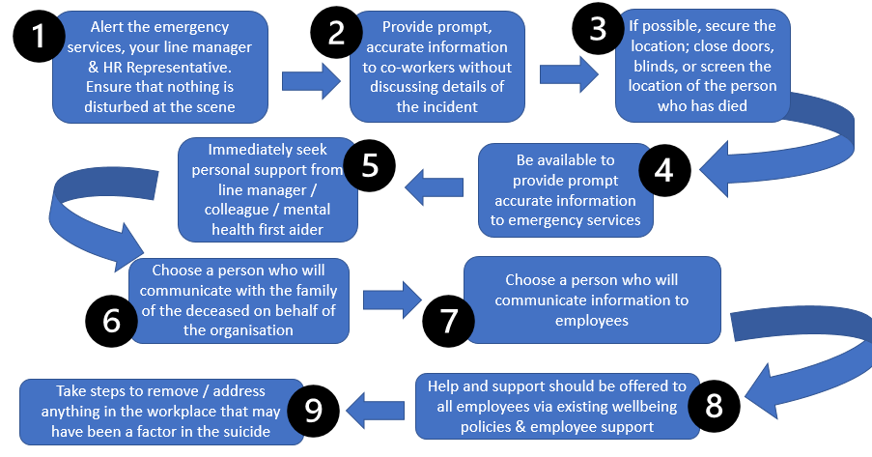
¹ Reference your HR emergency procedure policy here (if you have one)
² Provide contact details for your Mental Health First Aiders (if you have them)
³ Free training for anyone in this position is available via MindEd: https://www.minded.org.uk/Component/Details/685257
⁴ See Samaritans Media Guidelines for guidance: https://www.samaritans.org/about-samaritans/media-guidelines/
e) Appendix E: Process to follow for attempted suicide within the workplace
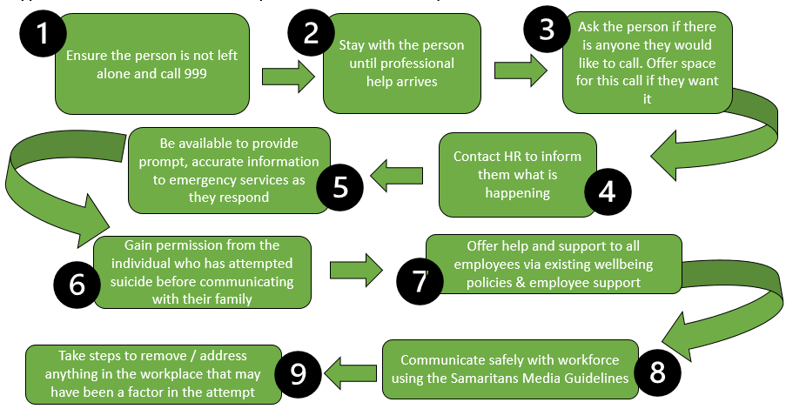
¹ Reference your HR emergency procedure policy here (if you have one)
² The Herefordshire and Worcestershire Health and Care Trust have a guide to support close friends and families after a loved one has attempted suicide. You may find this useful to share with staff. https://www.healthyminds.whct.nhs.uk/resources-and-other-support
³See Samaritans Media Guidelines for guidance: https://www.samaritans.org/about-samaritans/media-guidelines/
Appendix F: Guidance on impact of suicide and suicide attempt upon an operational site/place of work
GUIDANCE:
- Consider that an internal location may need to be secured for a period of time and have in place the ability to be able to secure the location and move employers elsewhere. How you would support your employees?
- Consider how your organisation would deal with an incident, that may require the external and/or customer facing element of the workplace to be out of operation for a period of time, and what support you could offer employees/customers.
- Consider housekeeping that may be required following a suicide attempt or suicide in the workplace and incorporate this within crisis management or emergency planning procedures.
- Health and Safety Review and risk – consider what internal procedures you would put in place to capture any organisational learning from an incident.
- Consider the support required for individuals undertaking this work, which may be distressing.

GUIDANCE:

In the aftermath of a suicide or suicide attempt some vulnerable individuals in the workplace may find this period very difficult. Avoid providing any details on the means of death or attempt, support individuals who you know to be at risk, and minimise misinformation. Careful, timely, respectful and sensitive communication can help to dispel rumours.

- Following consultation with the family, ensure that dealing with external media interest and internal communication are included within crisis management procedure, to provide a professional response to any media enquiries that may arise; and to provide sensitive communication to colleagues and the workforce – highlighting support available.
- Provide accurate information about the death of an employee and avoid the possibility of misinformation or rumours.
- Acknowledge that some information may spread quickly through informal communication, social media etc.
- Consider who will inform work colleagues of the deceased (or injured) - particularly close friends and team members.
- It is unfortunate that an incident of this nature may attract external media interest, and that employees or the organisation may be approached for a comment. A clear communications protocol could avoid misinformation and distress.

The World Health Organisation provides guidance for reporting on suicide specifically targeted for media professionals that can be viewed here.

