SEND Support Plan for


CHILD’S NAME

PHOTO HERE

SCHOOL NAME
LOGO HERE | Address |  | Telephone number
LOGO HERE | Contact Person/Position |  | Email Address

Name

Date of Birth

Year Group

Address

Post Code

Ethnicity

Religion

Home Language

GP Name

GP Address

Attendance

Fixed Term Suspensions




those with parental responsibility

Name

Relationship to Child

Address

Phone Number

Email Address

Name

Relationship to Child

Address

Phone Number

Email Address

Cared for by the LA. Details of Social Worker



SEN Status (highlight as appropriate)

SEN Support EHCP

EY GR 1 2 3 4

Enhanced Provision Top Up Funding

SEN type
Communication & Interaction | Cognition & Learning | Social, Emotional & Mental Health | Sensory & Physical Disabilities

SEN need
Specific Learning Difficulty (SpLD) | Moderate Learning Difficulty (MLD) | Severe Learning Difficulty (SLD) | Profound and Multiple Learning Disability (PMLD)
Speech, Language or Communication Need (SLCN) | Social, Emotional and Mental Health (SEMH) | Autistic Spectrum Disorder (ASD) | Visual Impairment (VI)
Hearing Impairment (HI) | Physical Disability (PD) | Multi-sensory Impairment (MSI) | Other Difficulty/Disability



who support me

Name

Role

Date of Involvement

Email Address

Name

Role

Date of Involvement

Email Address

Name

Role

Date of Involvement

Email Address

Name

Role

Date of Involvement

Email Address

Plans or Assessments
 |  | Y/N | Date initiated | Date completed/ Ongoing

Early Help

Child in Need

Child Protection

Care Plan / Personal Education Plan (cared for)


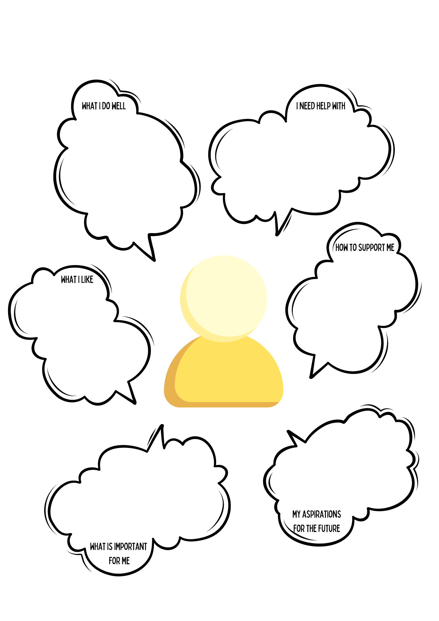
Text here
Text here
Text here
Text here
Text here
Text here



To include IEP review date with pupil and parents

Date | Key people | Notes | Outcome/Action

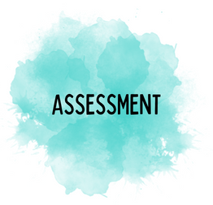

PRIMARY

Summary of Special Educational Needs
An overview of needs, the diagnoses, and the educational implications for the child/young person

Early Years Foundation Stage Summary
Listening, Attention & Understanding |  | Gross Motor Skills |  | Number |  | Creating with Materials
Speaking |  | Fine Motor Skills |  | Numerical Patterns |  | Being Imaginative & Expressive
Self Regulation |  | Comprehension |  | Past and Present
Managing Self |  | Word Reading |  | People, Culture & Communities
Building Relationships |  | Writing |  | The Natural World

Teacher Assessments Primary
Termly results
 | Year 1 |  |  | End of KS1  Year 2 |  |  | Year 3 |  |  | Year 4 |  |  | Year 5 |  |  | Year 6
Reading
Writing
Maths

SECONDARY

Summary of Special Educational Needs
An overview of needs, the diagnoses, and the educational implications for the child/young person
Teacher Assessments Secondary – KS3
 | KS2 | KS3 Target Grade | Year 7 Results (termly) |  |  | Year 8 Results (termly) |  |  | Year 9 Results (termly) |  |  | KS3 Teacher Assessment Grades
English
Maths
Science
RE
History
Geography
MFL
Other

Teacher Assessments Secondary – KS4
 | KS4 target Grade | Year 10 Results (termly) |  |  | Year 11 Results (termly) |  |  | Predicted Grade
English
Maths
Science
RE
History
Geography
MFL
Other

Assessment Data – all ages
Additional assessments which have been carried out in line with the child or young person’s individual need(s).
 | Previous Results |  |  | Current Results
Area Assessed | Assessment Used | Date | Raw Score, Percentile, Standardised score | Assessment Used | Date | Raw Score, Percentile, Standardised score

Individual Education Plan: Assess- Plan-Do-Review

photo | Child/Young person’s name: | Year Group & Class Teacher: | Date/Term:
photo | Level of Support:  SEN Support / EHCP | Area of Need (highlight)  Cognition & Learning Communication & Interaction  Social, Emotional & Mental Health Physical & Sensory

Area of need:
Target/Expected Outcome:
(What do we want X to achieve?)
Provision/Intervention Programme used:
(How are we enabling X to achieve?)
Frequency and delivered by:
Pre-assessment/Baseline Score:  Where are they now? Why do they need this provision?  Link to need | Half Term Progress
Post-assessment Score:  Actual Outcome including RAG  Have they met the expected outcome?  Green = accelerated progress/Amber = expected progress/Red = less than expected progress | End of Term Progress
Area of need:
Target/Expected Outcome:
(What do we want X to achieve?)
Provision/Intervention Programme used:
(How are we enabling X to achieve?)
Frequency and delivered by:
Pre-assessment/Baseline Score:  Where are they now? Why do they need this provision?  Link to need | Half Term Progress
Post-assessment Score:  Actual Outcome including RAG  Have they met the expected outcome?  Green = accelerated progress/Amber = expected progress/Red = less than expected progress | End of Term Progress
Area of need:
Target/Expected Outcome:
(What do we want X to achieve?)
Provision/Intervention Programme used:
(How are we enabling X to achieve?)

Frequency and delivered by:
Pre-assessment/Baseline Score:  Where are they now? Why do they need this provision?  Link to need | Half Term Progress
Post-assessment Score:  Actual Outcome including RAG  Have they met the expected outcome?  Green = accelerated progress/Amber = expected progress/Red = less than expected progress | End of Term Progress

Support & Intervention received this term

Parental Contribution

Teacher Signature | Parent Signature | Date
End of term pupil voice
Something that has helped me | Something I have got better at | Something I would like to improve

