Example Project Information

Before you start your project:
Using the first half of this template, detail all the information required for your project, before you begin

Project Name:
Co-production Quality Assessment Tool

Service/ Team/ Department:
AAD- SEND Co-production Team

Lead person:
Amy Knight and Chanika Benain

Aim of project:
To provide a universal tool to allow all participants of co-production projects to assess the quality of co-production within a project. To encourage development of co-production within the Local Area Partnership, learning from other participants.

Outcomes
Which outcomes will this project link to? (delete/ highlight as needed)
- I feel welcome, included and part of a community where I belong
- I am listened to, understood and involved in decisions about my life

Level of Participation
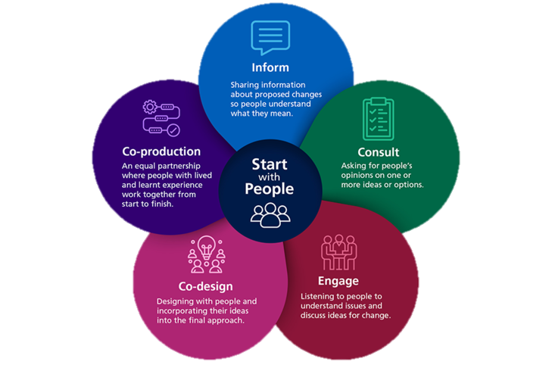
Which level of participation is expected in this project? (delete/ highlight as needed) It can be multiple levels.
- Consult
- Co-design
- Co-produce

Expected project outputs
What are you expecting to achieve in this project?
- A mechanism which can be used by all participants to assess the quality of co-production.

Expected project outcomes
What are you expecting to change for children and young people in this project?
- All participants feel confident sharing their opinions
- CYP know how to challenge the quality of co-production within a project, using an evidence-based tool.
- CYP feel empowered to assess co-production

Expected project impact
What are you expecting to change for your service/ team/ department in this project?
- Co-production can be implemented by all services, as there is a clear expectation. This increases the likelihood of teams doing this, leading to service improvements.

Evidence to be collected
What data/ information are you going to collect to evidence the outcomes and impact of this project?
- Survey of participants after the first 4 meetings for feedback and assessment of the work achieved so far.
- Piloting work with staff in differing organisations to allow clear feedback on the usefulness of the tool.

List of Participants invited
Using the stakeholder mapping tool (if you wish), who are you involving in this project? How many ‘groups’ have you included? (groups could be: Children and young people; parents/ carers; other service leads with County Council; NHS colleagues; ICB commissioners; teachers; VCS colleagues)
- Members of SEND co-production team
- Worcester Parent Carer Forum representatives
- CYP from Voices United Forum

After your project:
Complete this half of the template when you have completed the project, or are near to finishing it.

Participants involved
Who was involved at different stages of this project?
- Members of SEND co-production team
- Worcester Parent Carer Forum representatives
- CYP from Voices United Forum
- Public Health service lead
- NHS service lead
- SEND services manager

Level of Participation
What levels of participation were included?
- Inform
- Consult
- Co-design
- Co-produce

Project Outputs
What did you achieve in this project?
- Creation of a tool for all projects to assess the quality of co-production within a project.
- A scoring framework created to enable confidence in how to score different levels of co-production

Project Outcomes
What changed for children and young people in this project?
- Increased confidence to speak in a group of people
- Increased ability to constructively challenge
- Improved understanding of services within the local area partnership
- Greater confidence that staff within organisations listen, hear and value what they say

Project Impact
What changed for your service/ team/ department in this project?
- Increased network of families that want to work with the team. Greater trust in the delivery of ideas suggested by those families.
- A tool that can gather co-production information in a clear, manageable way that will help all teams to assess the quality of the co-production of their project. This enables simple data analysis for the team, as they need oversight of this information for reporting purposes.

Evidence collected
What data/ information was collected to evidence the outcomes and impact of this project?
- Conversations that were minuted with the Voices United forum members
- MS forms survey for all participants asking about the changes they have experienced and seen
- Piloting surveys and conversations with staff.

What have you learned from completing this project?
If you were to share the main things you have learned from this project, what would they be?
- Co-production can be lengthy, but not all aspects of the project have to be co-produced.
- There needs to be good planning as information needs to be shared early to allow for genuine involvement by all people.

Overall outcomes
Which outcomes were affected by this project? (delete/ highlight as needed)
- I feel welcome, included and part of a community where I belong
- I feel safe and supported
- I am listened to, understood and involved in decisions about my life
- I enjoy life, have fun and I am supported to reach my full potential

Additional comments
I need to take more photos in my next project, as I missed opportunities to show how people were working together in ways I hadn’t expected. Some participants want to be involved in the next project we do, as they enjoyed the process- even the hard parts!

