Project Information Template

Before you start your project:
Using the first half of this template, detail all the information required for your project, before you begin
IMPORTANT: Please fill in this Microsoft form which will inform Amy and Chanika (Co-production Officers) of your new project: Co-production/Participation Project Form

Project Name:

Service/ Team/ Department:

Lead person:

Aim of project:

Outcomes
Which outcomes will this project link to? (delete/ highlight as needed)
- I feel welcome, included and part of a community where I belong
- I feel safe and supported
- I am listened to, understood and involved in decisions about my life
- I am helped to be healthy in my mind and body
- I enjoy life, have fun and I am supported to reach my full potential

Level of Participation
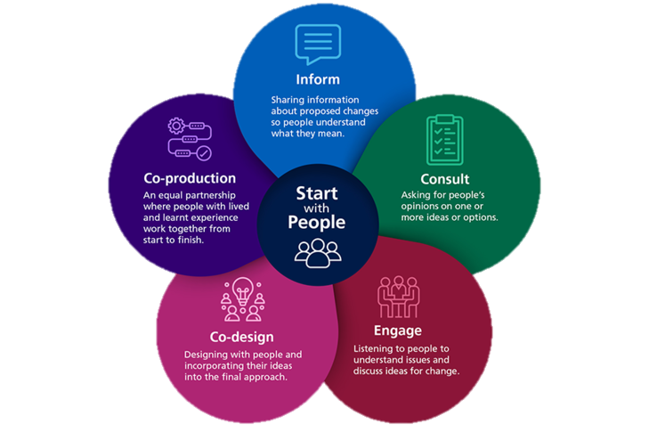
Which level of participation is expected in this project? (delete/ highlight as needed) It can be multiple levels.
- Inform
- Consult
- Engage
- Co-design
- Co-produce

Why have those participation levels been chosen?

Expected project outputs
What are you expecting to achieve in this project?

Expected project outcomes
What are you expecting to change for children and young people in this project?

Expected project impact
What are you expecting to change for your service/ team/ department in this project?

Evidence to be collected
What data/ information are you going to collect to evidence the outcomes and impact of this project?

List of Participants invited
Using the stakeholder mapping tool (if you wish), who are you involving in this project? How many ‘groups’ have you included? (groups could be: Children and young people; parents/ carers; other service leads with County Council; NHS colleagues; ICB commissioners; teachers; VCS colleagues)

After your project:
Complete this half of the template when you have completed the project, or are near to finishing it.

Participants involved
Who was involved at different stages of this project?

Level of Participation
What levels of participation were included?
- Inform
- Consult
- Engage
- Co-design
- Co-produce

Project Outputs
What did you achieve in this project?

Project Outcomes
What changed for children and young people in this project?

Project Impact
What changed for your service/ team/ department in this project?

Evidence collected
What data/ information was collected to evidence the outcomes and impact of this project?

What impact has this project had on the participants involved in the project?
What data/information was collected to show the evidence of impact for the participant? Has this impacted their confidence, skills? Do they want to be involved in future projects? Please provide evidence. This can be presented however the participant has chosen to use e.g. voice note, Microsoft form, survey, informal chat, photos, recorded video’s etc. Please refer to the ‘collecting evidence’ document for further ideas.

What have you learned from completing this project?
If you were to share the main things you have learned from this project, what would they be?

Overall outcomes
Which outcomes were affected by this project? (delete/ highlight as needed)
- I feel welcome, included and part of a community where I belong
- I feel safe and supported
- I am listened to, understood and involved in decisions about my life
- I am helped to be healthy in my mind and body
- I enjoy life, have fun and I am supported to reach my full potential

Additional Comments?

If you would like any support with co-production/participation, please email Amy and Chanika: sendco-productionteam@worcestershire.gov.uk

