What evidence could you collect?
Evidence is required when reporting on projects. The question is though, what can you collect?
There are two types of evidence
- Quantitative
- Qualitative
It is best to try to collect both, as one allows for analyse and the other provides a more descriptive evidence base. What is applicable to your project, will be best decided by you.

Reporting in general
- Statistical data (useful to measure outputs)
- Photos e.g. change of a room through a design process
- Personal stories e.g. most significant change Most significant change | Better Evaluation
- Timelines e.g. change in number of staff
- change over time e.g. feelings over time – at the end of every meeting participants are asked to note 3 words to describe their feelings
- interviews e.g. focused questions showing how your service improved their mental health
- Group or solo feedback opportunities
- sound recordings
- videos e.g. describing their role within project meetings and what skills this has developed
- transcripts
- survey/ questionnaire e.g. feedback on navigating a website
  - open and closed questions
- reflective journal entries e.g. different participants asked to note different aspects over the course of a project

The key is to decide how you will collect evidence about the people using the service; the participants in the project; the family of the person using the new device rather than evidence about what you have done. Both have value, but the first is most important.

Example
Project: Youth tutoring
Description: To improve the academic performance of students through increasing their knowledge and skills, school attendance and time devoted to schoolwork, by providing additional academic guidance and instruction.
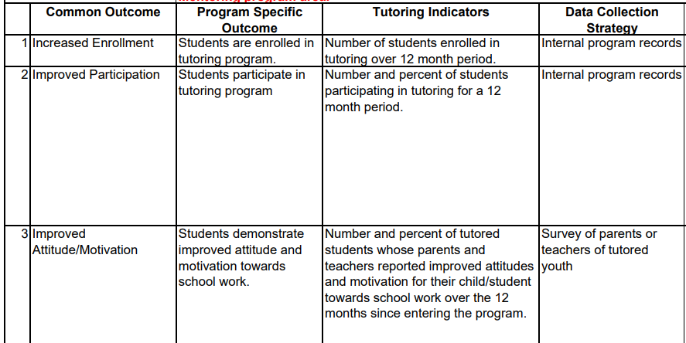

Reporting on Co-production
The most comprehensive place to look at how to score the quality of the co-production in a project is to look at the scoring framework for co-production. Some of the examples are listed below:
- Roles and boundaries are written down and decided collectively
- Co-created meeting rules
- Power imbalance is discussed and addressed
- Lived experience ideas are shown to lead to action
- Voices are creatively collected to allow all to take part
- Skills developed within the project are used elsewhere
- Reasonable adjustments are recorded and embedded
- People can actively articulate what they have learned in the process
- Meetings are inclusive and this is regularly reviewed
- A glossary is available and is updated
- Progress updates are shared showing actions linked to suggestions
- Feedback mechanisms are regular and help to shape decisions
- Calendars are agreed together e.g. meeting dates and times; deadlines
- Training and support is offered and is individualised
- Impact reviews happen with all participants

To enable you to score it and then provide evidence, you need to collect the necessary information. For example, for the first bullet point above (Roles and boundaries are written down and decided collectively) the Terms of Reference document could provide this. You could also ask specific questions in a survey of participants. Or you could interview different people and video their answers. You decide what is easiest for your project.
The bullet points above show the ‘perfectly’ co-produced project. Using them as a guide will show what type of evidence might be need to be collected.

